Edina Trust Bulb Project Extension
Guidance Teachers and Project Leaders on this Year’s Results
A big thank you!
Well done to all schools that sent data for the Bulb Project this year! Your input has been invaluable in looking at our hypotheses. Even if you did not manage to get data to us this year we hope that this project has been fun and useful for teaching various curriculum topics. We have a quick survey online where we would love to get your feedback:
https://www.surveymonkey.co.uk/r/JFQWV66
The National Museum of Wales (NMW) will produce a paper on the results of the bulbs planted in pots for all schools. This will be distributed to the schools involved and can be accessed on the NMW website: www.museumwales.ac.uk/spring-bulbs/
This year 100 schools took part in the Edina Trust’s extension Bulb Project, which involves comparing the flowering dates and heights between bulbs planted in pots and bulbs planted in the ground. A big thank you to the schools that returned their flowering data!
Table 1: Data sets for the Edina Trust Bulb Project Evaluation
 | Schools in Extension Project | Schools in Scotland | Schools in England | Schools in Nor. Ireland | Schools in  Wales
All Schools | 100 | 29 | 41 | 25 | 5
Schools that provided flowering data | 33 (33%) | 13 (45%) | 16 (39%) | 2 (8%) | 2 (40%)

The amount of data is significantly lower than normal due to the lockdowns. This could have affected the reliability of the data, especially in Northern Ireland and Wales where we only had results from two schools in each country, which could be an interesting point for discussion. In the following analysis, local authorities have been divided into the four countries:
- Scotland: Dumfries & Galloway, East Ayrshire, Fife, North Lanarkshire, Renfrewshire, Scottish Borders, West Dunbartonshire, West Lothian
- England: Hull, Knowsley, Lancashire, Lincolnshire, North East Lincolnshire, Oxfordshire, Wakefield, Wolverhampton
- Northern Ireland: Belfast, Derry/Londonderry, Strabane, Fermanagh, Omagh, Newry, Mourne and Down
- Wales: Blaenau Gwent, Caerphilly, Conwy, Rhondda Cynon Taf
The following pages contain further details on the results, which you can use alongside the PowerPoint presentation to share the results with pupils. If your school is still closed, pupils could work through the PowerPoint by themselves or you might consider sharing the presentation with the class e.g. by a Zoom meeting.
We have also created some fun quizzes that pupils can do by themselves, which don’t require them to use PowerPoint. You can find more information on page 9!
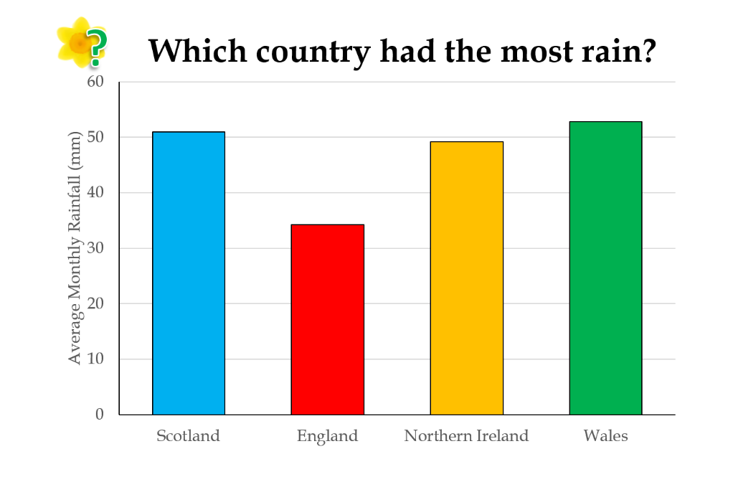

Country | Average rainfall (mm)
UK 2019 | 47
Scotland | 51
England | 34
N. Ireland | 49
Wales | 53
Wales had the most rain this year, although Scotland was very close too. To the right are the actual figures for each country, plus the combined average for the UK, as recorded by the schools taking part in the Bulb Project.

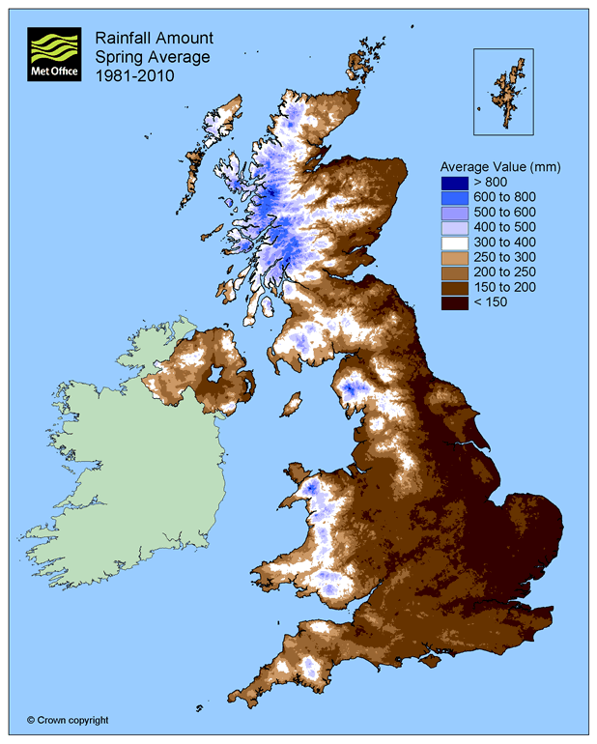
Wales being the rainiest area is not surprising – see the map to the left from the Met Office. The west of Scotland, North-West England, and Wales have the most rainfall on average in Spring.
https://www.metoffice.gov.uk/public/weather/climate

Water is of course vital for plants, but more rain does not always mean that daffodils will thrive. Daffodils will not grow underwater! Being too moist also benefits moulds that are detrimental to the daffodil bulbs.

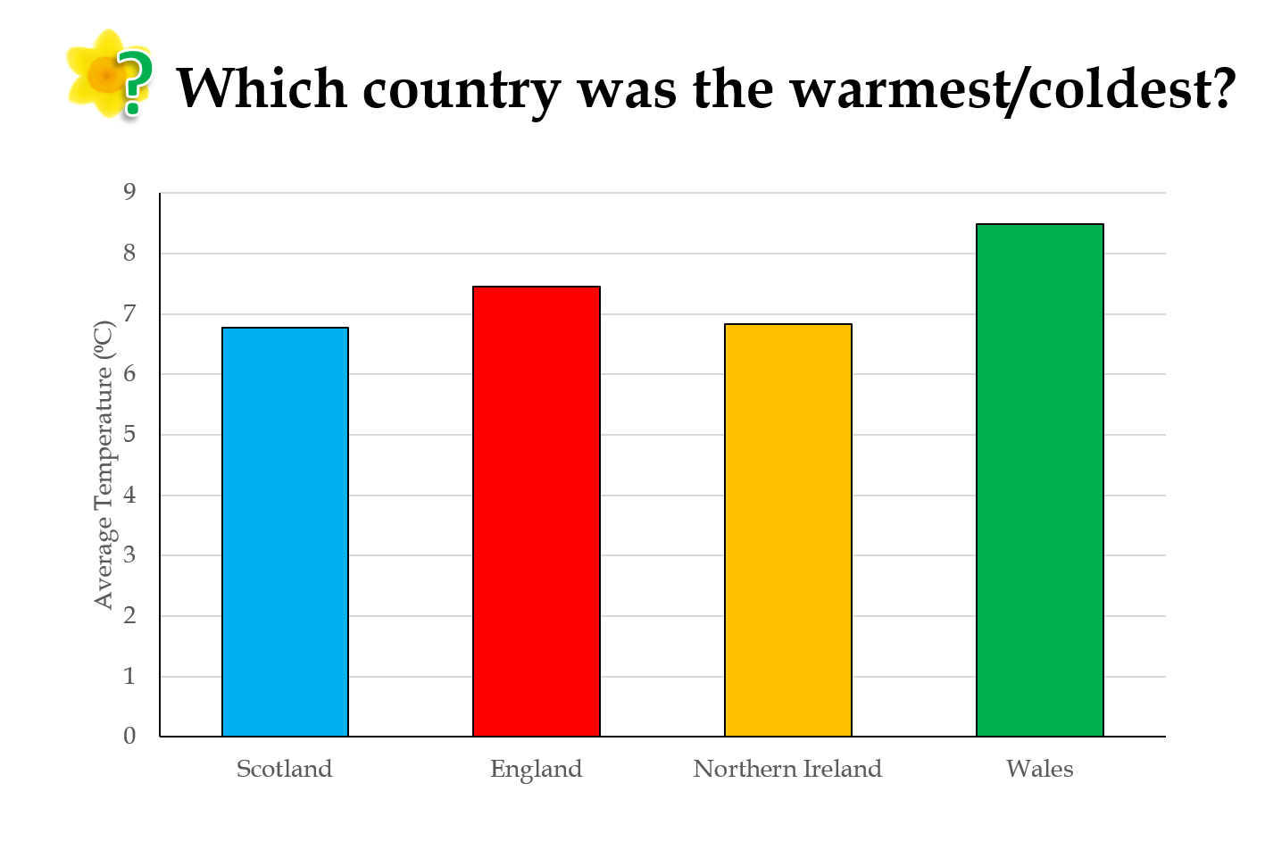

Wales was the warmest country this year on average. Scotland was once again the coldest area. This is due to its higher latitude. Another factor, although it probably wouldn’t affect children taking their weather recordings during the day, is that Scotland being further north has fewer daylight hours during the winter. South Wales and South England can also benefit from warm, tropical winds coming from the south, whereas Scotland gets cold Arctic winds coming from the north.
Country | Average Temperature (°C)
UK 2019 | 7.4
Scotland | 6.7
England | 7.5
N. Ireland | 6.8
Wales | 8.5

The table to the right shows the actual values for the average temperature in each country and across the UK.

Bulbs are sensitive to temperature changes and begin to grow as the soil warms up in spring. This means that a mild winter can cause daffodils to flower earlier, or a cold spring can cause them to flower later.

As with rainfall, it is not always good to be too warm. As well as potential drought, too much warmth can be beneficial to pests such as the Large Narcissus Fly. The fly’s larvae live inside and eat daffodil bulbs. Due to the warmer climate this fly, which was once only found in the South-West, has been able to spread across the UK.

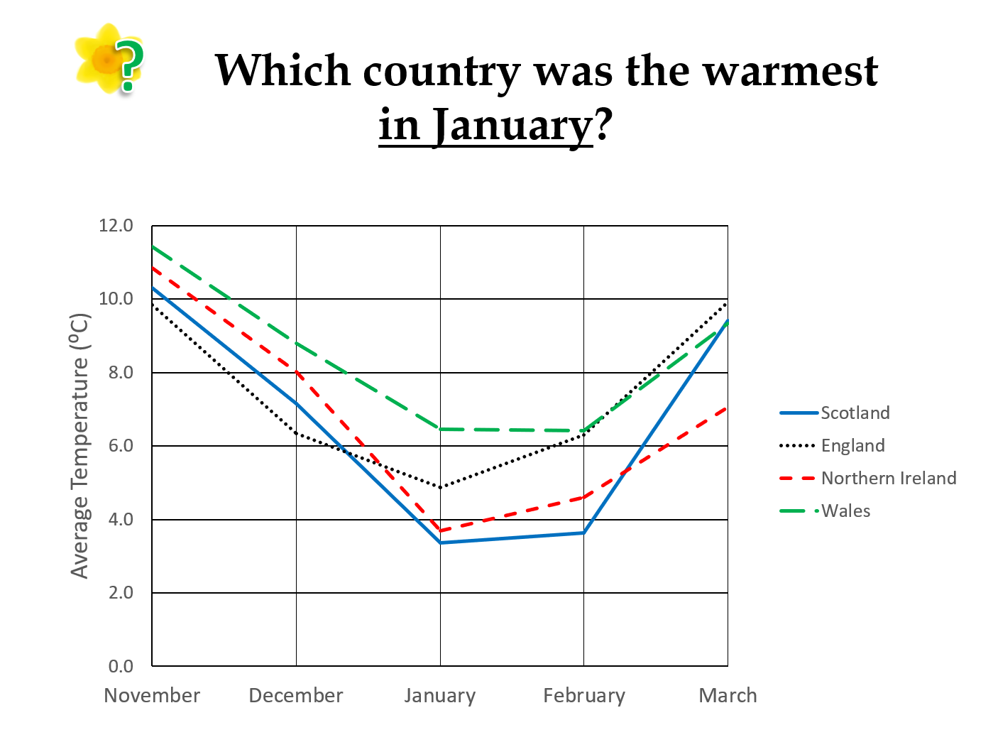

This graph shows the temperature each month from November 2020 – March 2021. We can see there was a decrease in temperature until January, and then the average jumped back up in March. Below are the average temperatures each month in the four countries:
ºC | November | December | January | February | March
Scotland | 10.3 | 7.2 | 3.4 | 3.6 | 9.4
England | 9.8 | 6.3 | 4.9 | 6.3 | 9.9
N. Ireland | 10.8 | 8.0 | 3.7 | 4.6 | 7.1
Wales | 11.4 | 8.8 | 6.4 | 6.4 | 9.3

Looking at January in particular, Wales was the warmest. Scotland was the coldest, but only slightly colder than Northern Ireland. Scotland also increased in temperature in March more than Northern Ireland – it had almost the same average temperature as England and Wales, while Northern Ireland became the coldest in March.

Our hypotheses
Next, we look back at our hypotheses – our predictions about daffodils’ flowering and height:
- Schools that record higher temperatures during the Bulb Project will have the earliest flowering daffodils. The effect of temperature will be more pronounced with the daffodils in pots compared to those in the ground.
- Schools that record more daily rainfall during the Bulb Project will have the earliest flowering daffodils.
- On average, daffodils in pots will flower before those planted in the ground.
- Schools in areas with higher temperatures will record taller daffodil flowering heights.
- Schools in the area with the highest level of rainfall will record taller daffodil flowering heights.
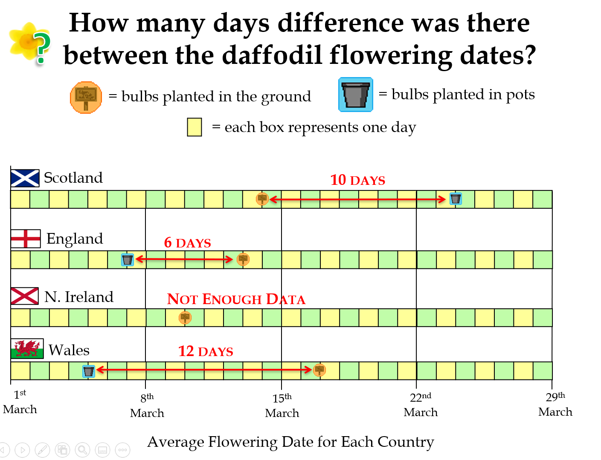
 | Pots | Ground
Scotland | 24th March | 14th March
England | 7th March | 13th March
N. Ireland | No data | 10th March
Wales | 5th March | 17th March
Daffodils flowered first in Wales, followed by Northern Ireland, England, and Scotland was the latest this year. The average flowering dates are listed in the table to the right.

Our hypothesis was that daffodils in pots would flower first. This happened in every country except Scotland, where daffodils in the ground flowered 10 days (on average) before those in pots. Last year, it was the opposite, where daffodils in Scotland that were planted in pots flowered first, and daffodils in the ground flowered first everywhere else. We aren’t quite sure why, but we’d love to hear your ideas if anything comes up in your classroom!

We expected that the bulbs in pots would be less insulated from changes in temperature and therefore bulbs in pots in the warmest area would flower much earlier than those in the ground, and in the coldest area there would be less of a difference. However the data does not entirely support our hypothesis, as bulbs planted in the ground flowered earlier in Scotland. It raises further questions as to what other factors had enough impact to override the temperature difference. We will come back to these other factors later.

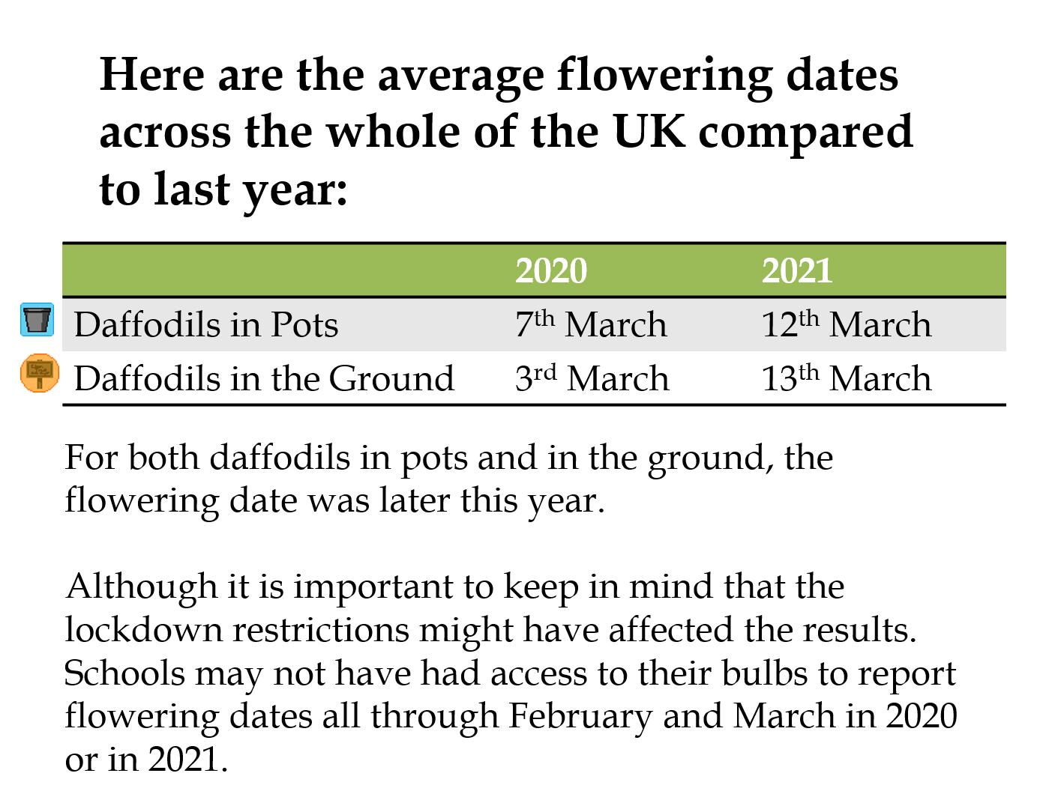

The slide shows the difference in flowering dates between bulbs in pots and in the ground, and between Spring 2019 and Spring 2020. These are the average flowering dates across the whole UK.

To the left is a graph showing the temperatures sent in by schools during the last three years of the Bulb Project. You can see that 2019-20 has been the warmest on average, yet daffodils flowered later this year. Possibly this was because the amount of rain or some other factor was more important, and/or the overall results have been affected by the lower number of schools sending in data.
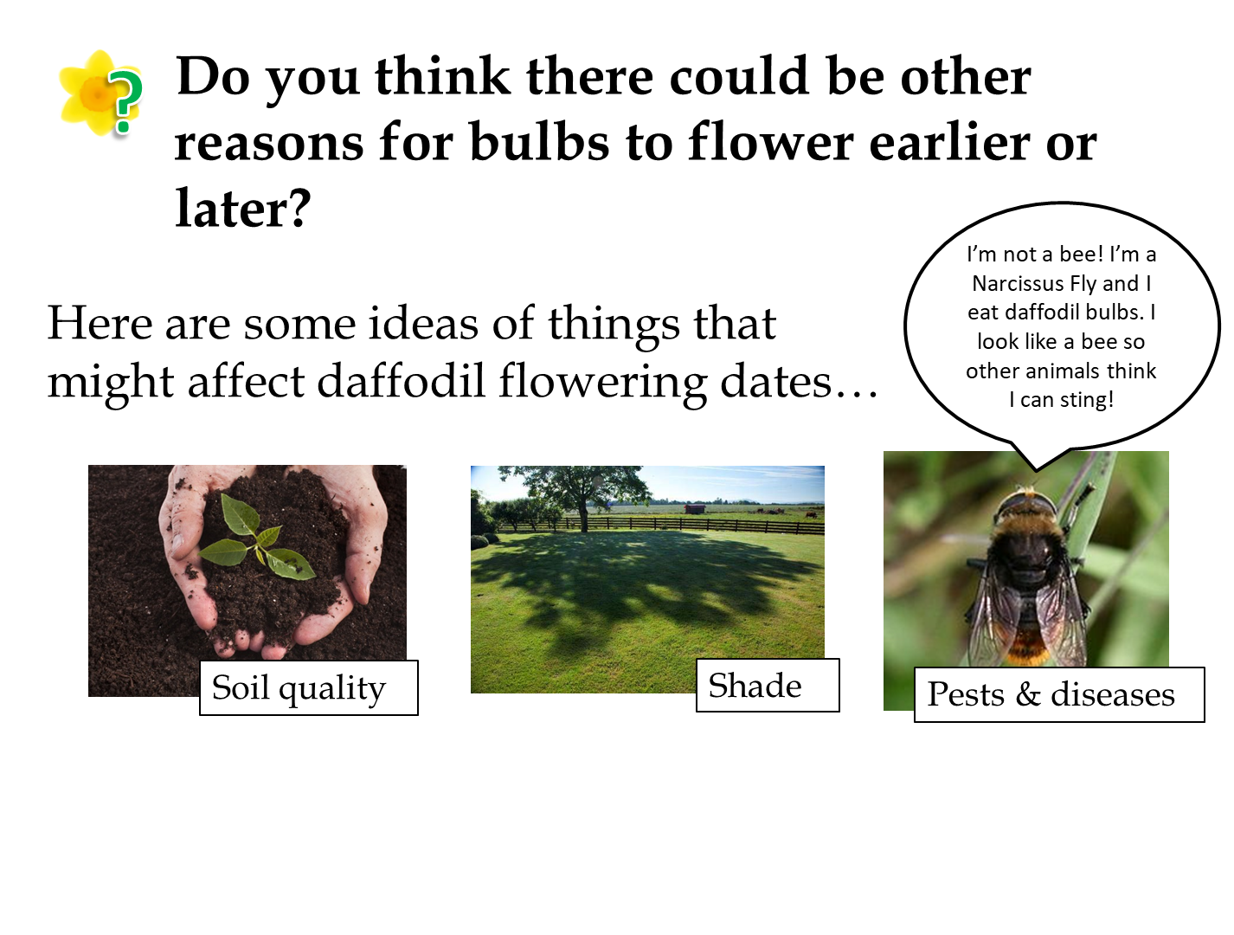

The slide shows some of our ideas for other factors that might be affecting the growth of the daffodils. They might explain why the results don’t always match our predictions.

- Soil Quality
We cannot be sure how much of an effect the type of soil or compost has on the growth of daffodils. Compost will hold moisture more effectively than soil, and different types of compost will hold moisture more effectively – we recommend peat-free compost due to environmental concerns. Using compost over soil should also reduce weed growth since it should not contain any stray seeds. Good drainage is important as waterlogged soil can cause the bulbs to rot, and the pH and amount of nutrients, e.g. nitrogen and potassium, in the soil will also affect growth. We would have to find a way for all schools to use the same compost to eliminate this from our investigation.

- Sunlight/Shade
Plants need sunlight in order to grow. Bulbs that are grown in shaded areas might grow taller in search of light, or they may not get enough sunlight to warm up and might flower later. We ask schools to keep their pots near the bulbs planted in the ground, if possible, to reduce the impact of this. There is not much else we can do as the amount of shade and hours of sunlight will differ between all schools.

- Pests and Diseases
We don’t have much control over this. We advise schools to keep their bulbs in a cool, dry place before planting day. Let us know if you notice your flowers are affected by pests!

Mystery Bulbs
Spoilers: the mystery bulbs this year were Aliums! Were you able to see the mystery bulbs flowering yet this year? They may open as late as May. We would like to encourage pupils to have a look for Aliums flowering near where they live as well!

Follow Up Activities

- Kahoot Quizzes
We have created some fun quizzes that pupils can complete using the website Kahoot! There are three different quizzes, relating to temperature and rainfall results sent in by pupils all around the UK. The links to these quizzes can be found at www.edinatrust.org.uk/bp-results
Please note these quizzes will be available a few days after the results PPT and this document are released.
We would love to hear your feedback!

- Bulb Project Board Game
A professionally printed copy of this game was sent to all schools last October. However, if you direct pupils to our website linked below, they will find a board game that can be downloaded and printed. This game is designed to encourage discussion about the various factors that could have affected the growth of your daffodils and crocuses.

Please go to this web page to download the board game and instructions:
https://www.edinatrust.org.uk/bp-results

- OPAL Air Survey
One of the factors that we have not looked at in the Bulb Project is the air quality. You may have read news reports that reveal quite shocking impacts that local air pollution can have on people and wildlife, for example: https://www.theguardian.com/environment/2018/nov/05/air-pollution-everything-you-should-know-about-a-public-health-emergency

If you are interested in the air quality around your school, there is a simple survey you can take part in that will also help provide important data to scientists. This is done by looking at lichens and fungi that are growing around your school and OPAL provides guidance to help you identify the different species.

Please go to this web page to find out how to take part in the OPAL Air Survey: https://www.opalexplorenature.org/airsurvey

Please note that the Edina Trust is not affiliated with OPAL or this Air Survey in any way, so if you have questions you will need to contact OPAL.

https://thedaffodilsociety.com/wordpress/a-guide-to-dafodils/pests-diseases/

